**SQL Developer Internship Documentation**

**Objective:** To use subqueries to extract insights from a dataset and perform data aggregations to summarize and analyse the data.

**Queries:**

**Database Setup:**

**Tables to Create:**

**1. Students:**

* Fields:
  + student_id: Primary Key.
  + name: Name of the student.
  + math_score: Math test score.
  + science_score: Science test score.
  + english_score: English test score.
  + 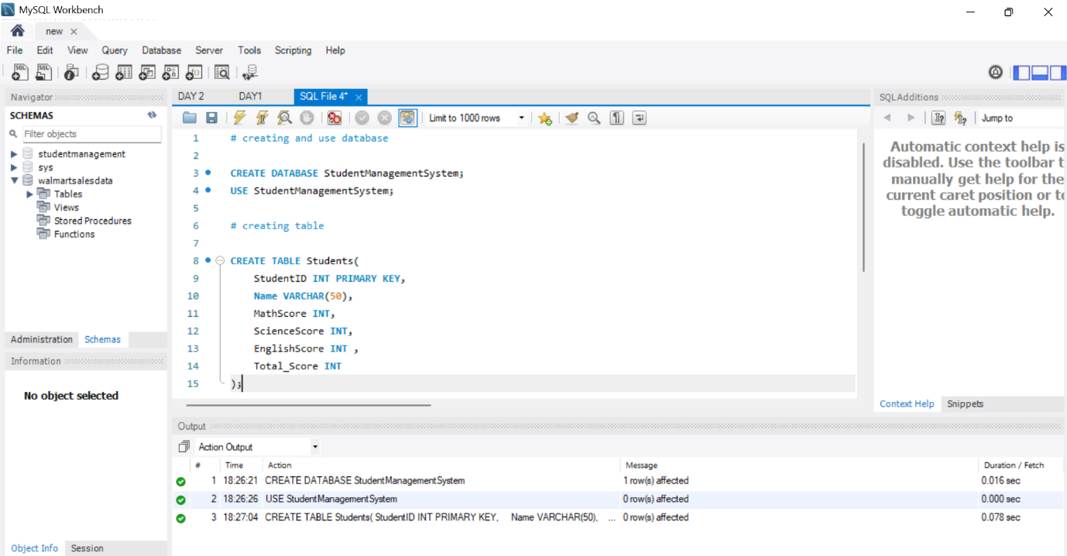total_score: The sum of all scores for each student (optional if calculated dynamically).

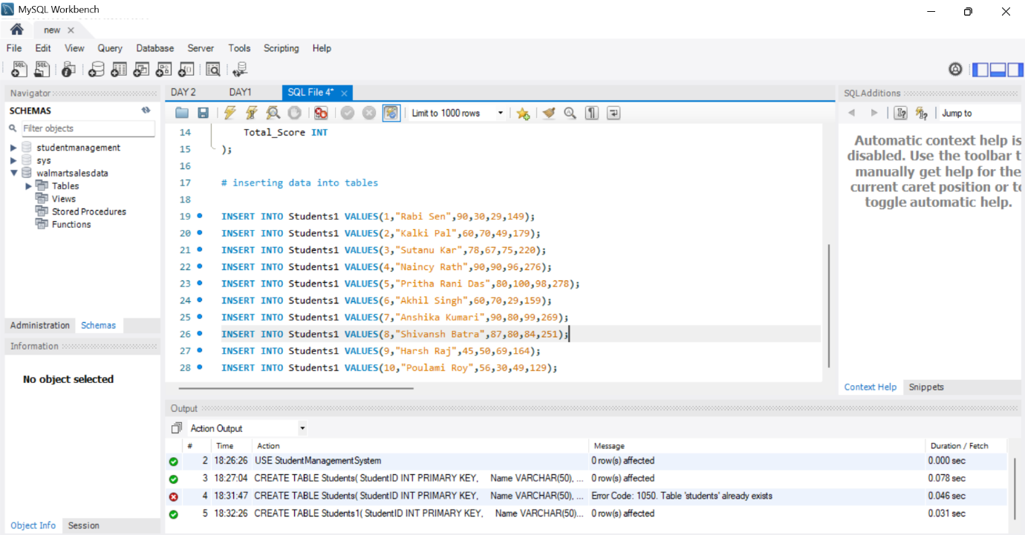

**Purpose of Creating Tables and Inserting Data:**

Creating the Students table and inserting data with scores for Math, Science, and English helps to organize student performance data efficiently. It allows for meaningful analysis and insights through queries, supporting effective data storage, retrieval, and manipulation.

**Tasks to Perform:**

**Task 1: Identify Top Students by Total Scores**

**Output:** This query provides a list of top students ranked by their total scores (math_score + science_score + english_score). It includes the top students and their total scores, showcasing the highest achievers.

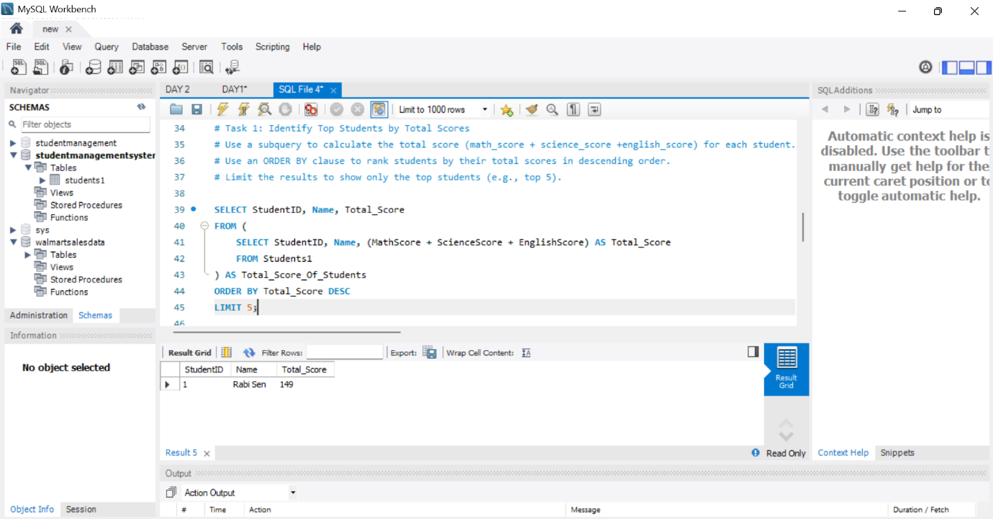

**Explanation:**

* The query uses a subquery to calculate the total score for each student.
* The ORDER BY clause ranks students based on their total scores in descending order.
* The LIMIT clause is used to display only the top students (e.g., top 5).

**Task 2: Calculate Averages Based on Specific Conditions**

**Output:** This query calculates averages for specific conditions:

* Average score of students who scored above 70 in Math.
* Average total score of students grouped by a specific condition, such as a score range (e.g., students scoring 200–250 in total).

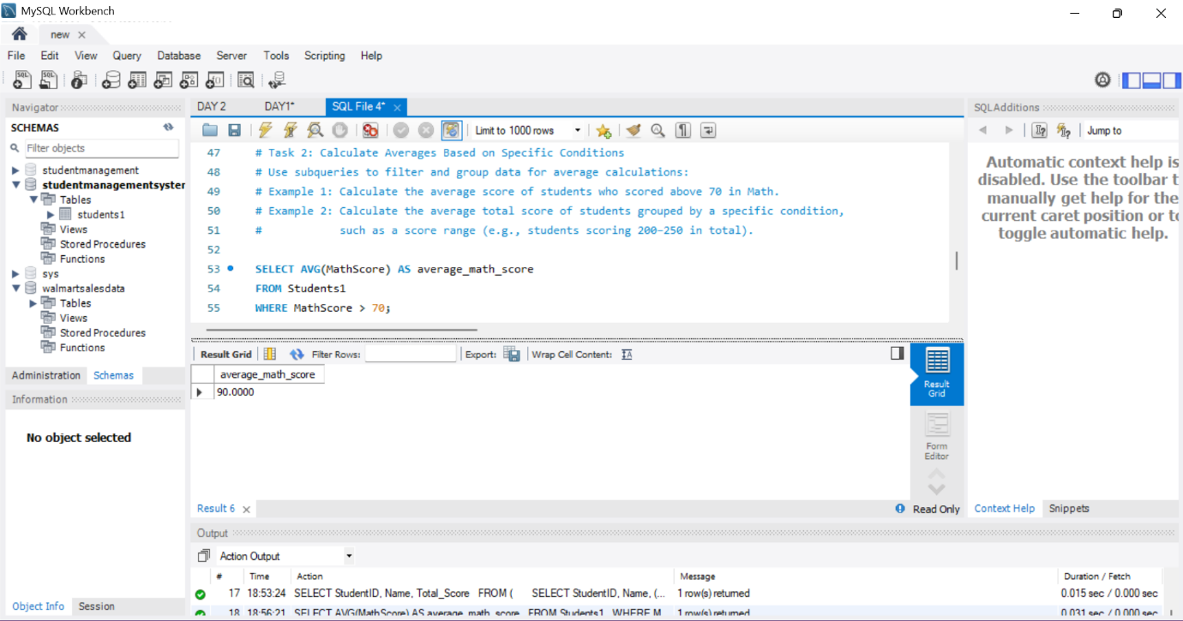

**Explanation:**

* Subqueries filter and group data for calculating averages based on conditions.
* The WHERE and GROUP BY clauses are essential for filtering and grouping the results.

**Task 3: Find Second-Highest Math Scores**

**Output:** This query finds the second-highest Math score among students. It helps identify students who are just below the top performers in Math.

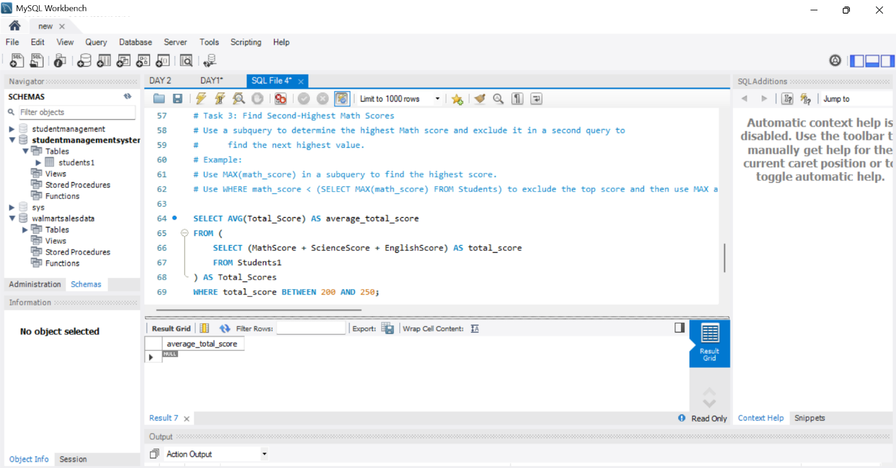

**Explanation:**

* A subquery is used to determine the highest Math score.
* The WHERE clause excludes the highest score, and then another MAX function identifies the second-highest score.

**Summary of Key Findings:**

1. **Top Students by Total Scores:** The first task identifies top-performing students based on their total scores, highlighting the highest achievers.
2. **Average Performance:** The second task provides insight into average student performance based on specific conditions, helping to understand trends in student scores.
3. **Second-Highest Scores:** The third task identifies students who have the second-highest Math scores, showcasing those just below the top performers.

**Main Flow Services and Technologies Pvt. Ltd.**

* **Contact No.:** +91 9389641586, +91 97736 99074
* **Email:** contact.mainflow@gmail.com
* **Website:** www.mainflow.in